PRACTICAL-4
OBJECTIVE – CREATE AN AWS LAMBDA FUNCTION
Steps to Create an AWS Lambda Function
1. Log in to AWS Management Console
• Go to AWS Console.
• Sign in with your credentials.
2. Navigate to AWS Lambda
• In the search bar, type Lambda.
• Click on Lambda service.
3. Create a New Lambda Function
• Click Create function.
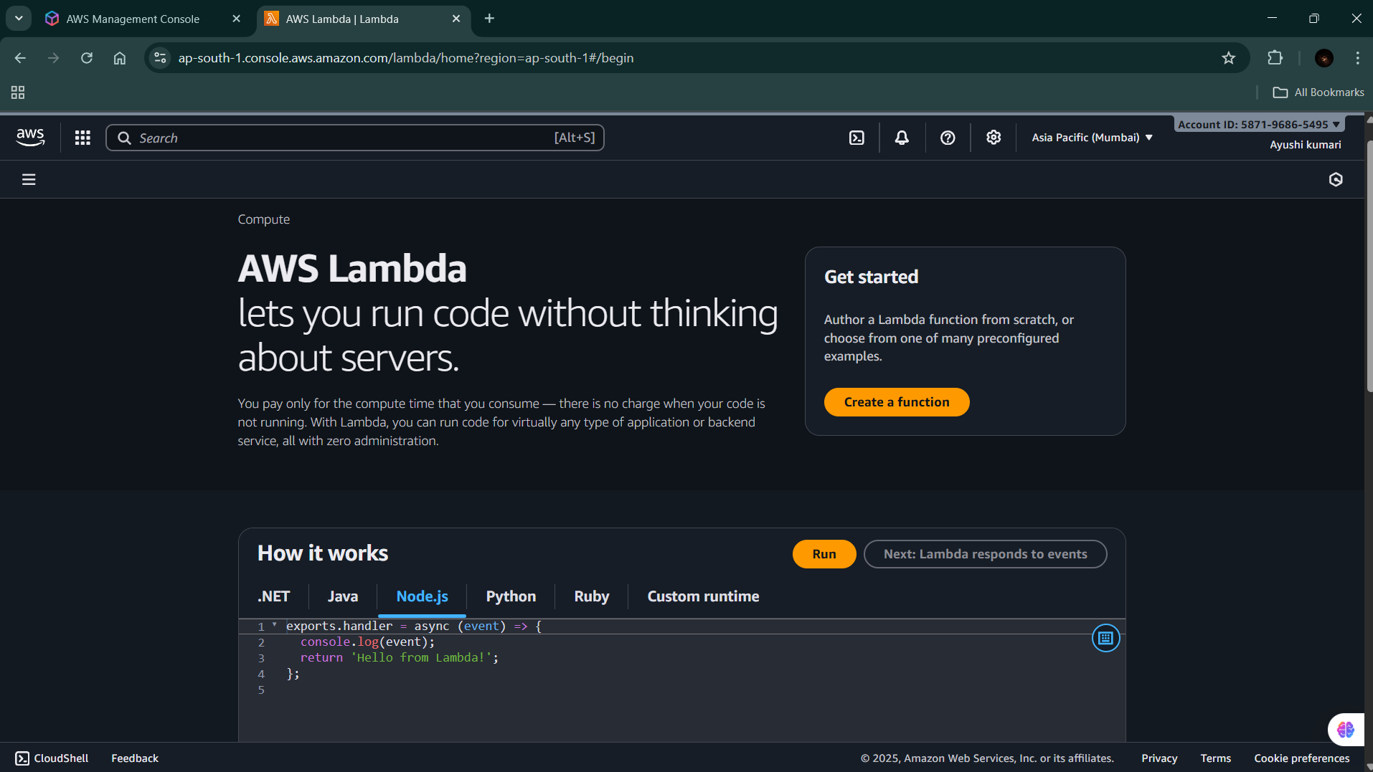

4. Choose a Creation Method You’ll see 3 options:
5. Author from scratch → (most common, start fresh).
6. Use a blueprint → predefined templates.
7. Container image → deploy code as Docker container.
8. Select Author from scratch.
9. Configure Basic Settings
• Function name: Enter a unique name (e.g., My-phlaFunction).
• Runtime: Choose a runtime (Node.js, Python, Java, Go, etc. → example: Python 3.9).
• Permissions (Execution Role):
o Create a new role with basic Lambda permissions (recommended if you’re new).
o Or choose an existing IAM role if you already have one
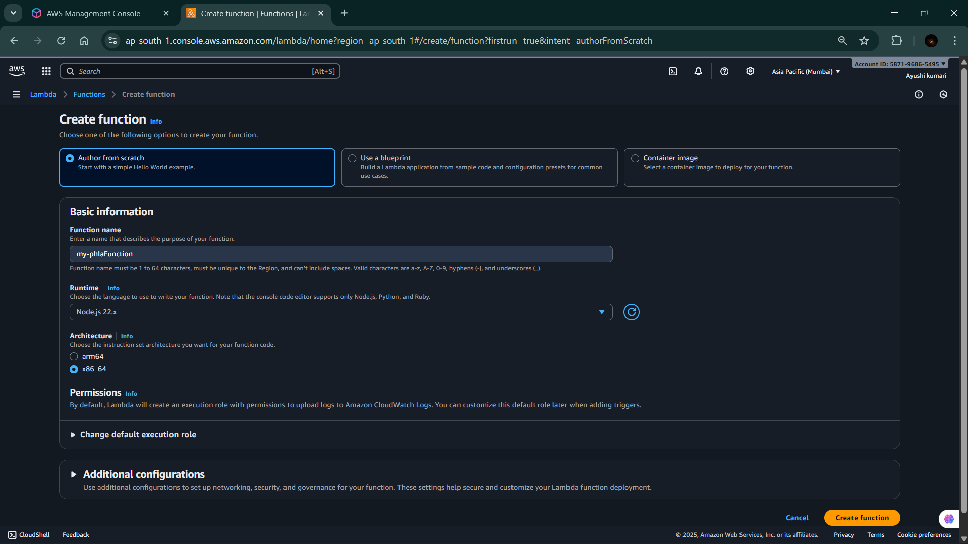

10. Click Create Function
• Wait a few seconds while AWS provisions the function.
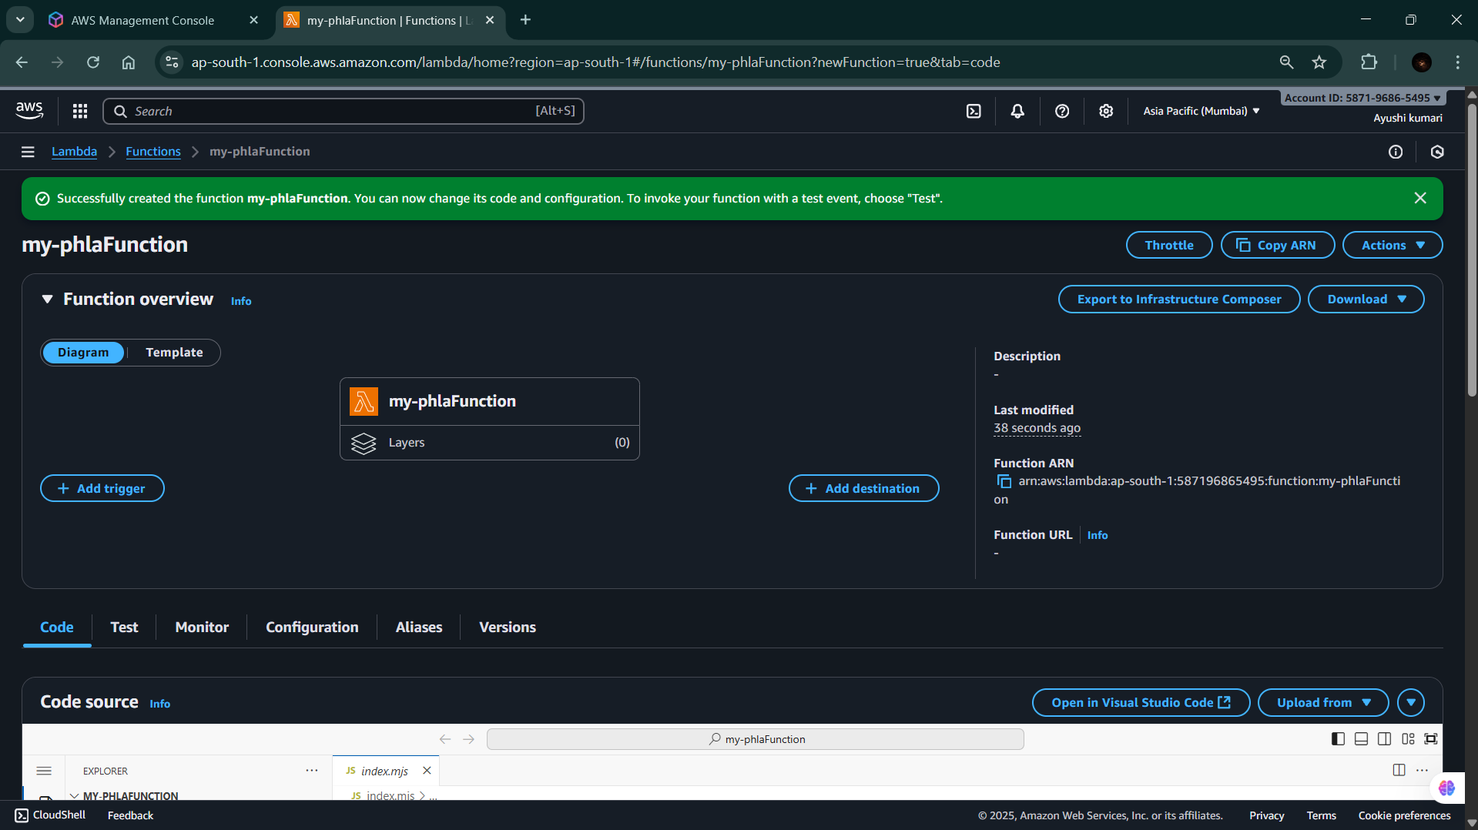
11. Add Your Code
• In the Function code section, you can:
- Write inline code in the editor.
- Or upload a .zip file.
- Or use Amazon S3 (if your code is stored there).
- Example default code in node js :
export const handler = async (event) => {
// TODO implement
const response = {
statusCode: 200,
body: JSON.stringify('Hello from Lambda!'),
};
return response;

8. Configure Test Event
- Click Test → Configure test event.
- Give it a name (e.g., Firstfunction).
- Keep the default event JSON or modify as needed.
- Save.

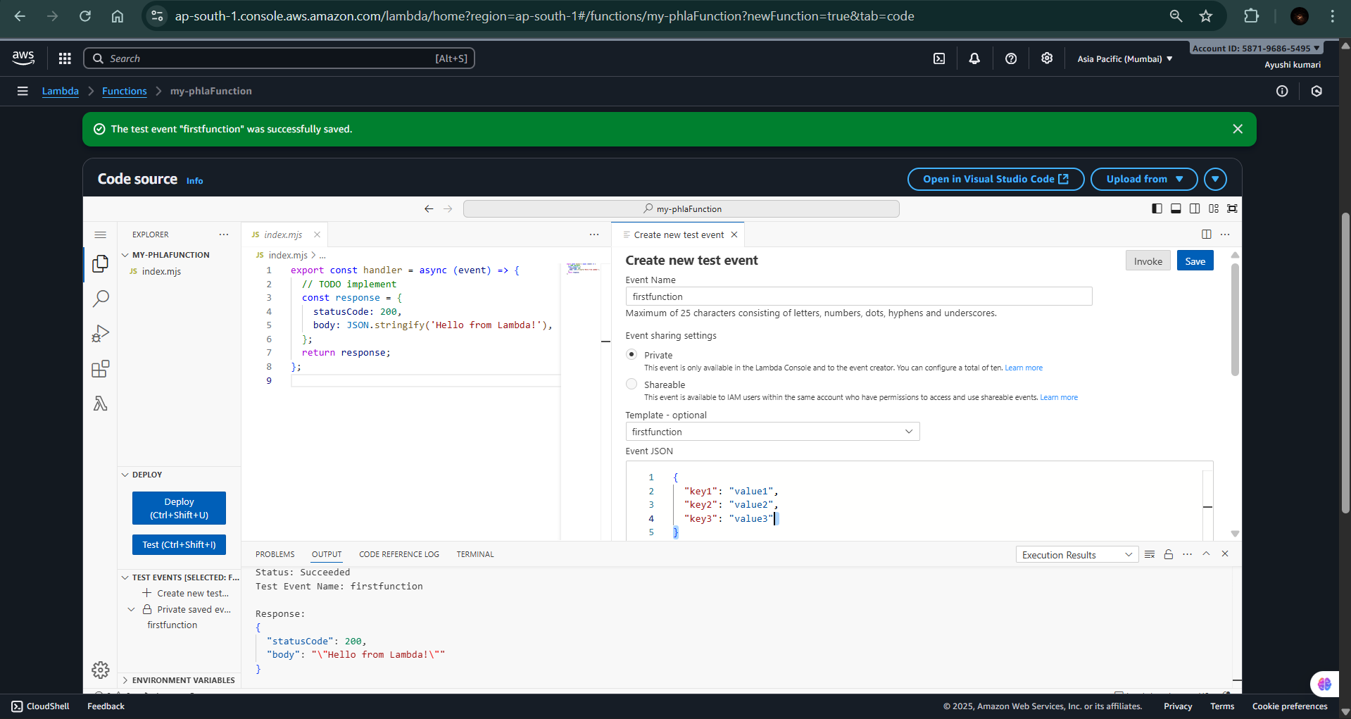

9. Run the Function
- Click Test again.
- Check the execution results (output, logs, and status).

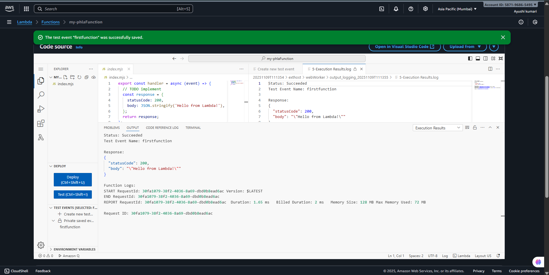

10. (Optional) Add a Trigger
- You can connect Lambda to services like:
  - API Gateway (for REST APIs)
  - S3 (trigger on file uploads)
  - DynamoDB (trigger on database changes)
  - EventBridge (scheduled events)

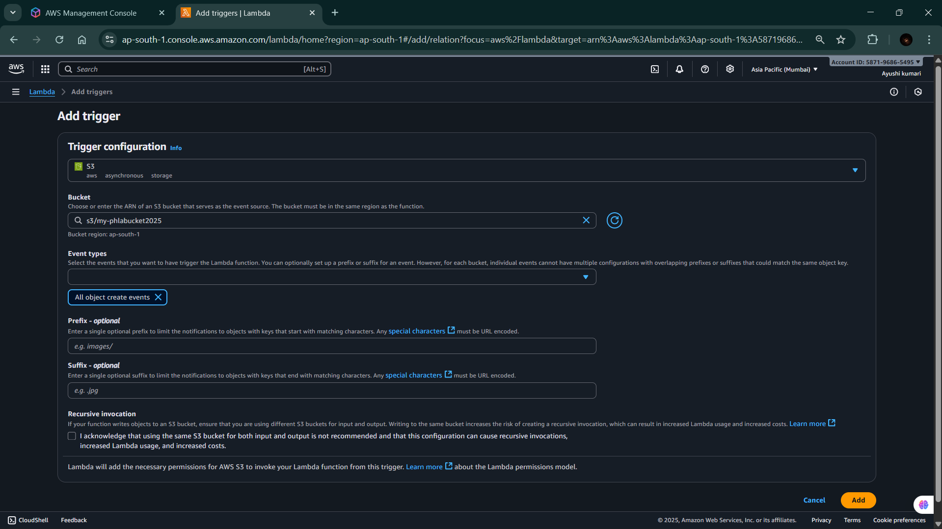

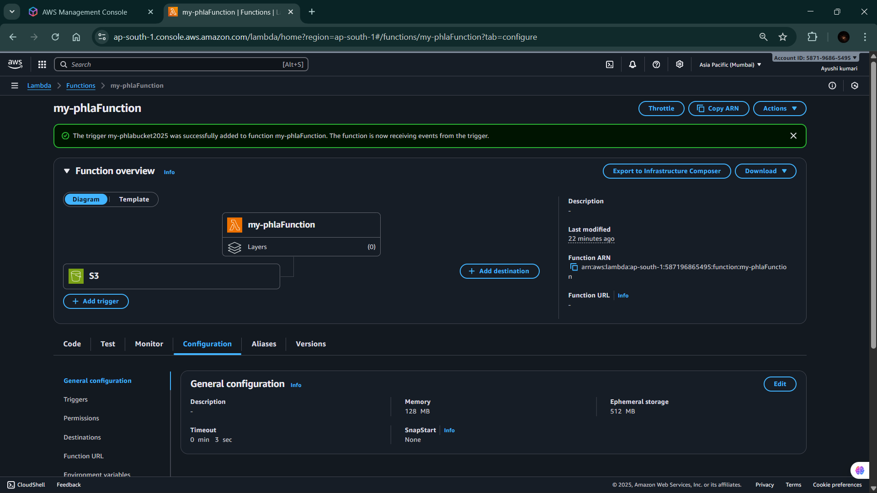
11. Successfully events scheduled.

